“Rudy” Movie Questions 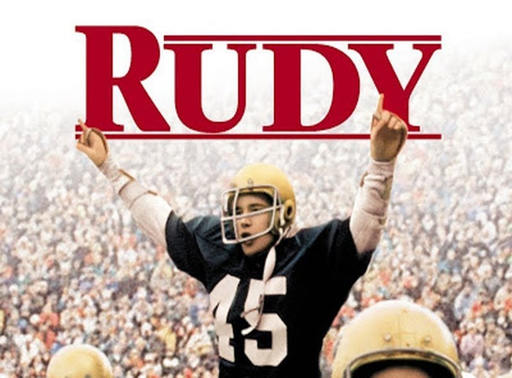

1). What was Rudy’s goal? What did the people around him think of his goal?
2) What happened (at the steel mill) that Rudy used as his source of motivation to pursue his goal?
3) Who (and what) were the negative people (and things) in Rudy’s life that tried to discourage him from pursuing his dream?
Bonus: Think about the negative people in your life. Who are they? Are they trying to discourage you in any way?
4) Who were some people that greatly influenced/impacted Rudy life?
5) What were some examples of Rudy’s short-term goals?
6) In order to accomplish your goals, sometimes you have to do whatever it takes. What were some things that Rudy did in order to accomplish his goals? What sacrifices are you willing to make in order to accomplish your goals?
7) How would you describe the Notre Dame Football team’s attitude towards Rudy?
8) Did Rudy achieve his goal? How or why/why not?
9) Name 3 events that could have impacted Rudy’s mental/emotional health.
10) What did Rudy do to deal with his stress?
11) What was the biggest take away for you? (The biggest wow moment/gave you goosebumps)
12) Why did Rudy struggle in school so much? (hint: It’s a learning disorder)

